Trent Giever

Debbie Wolf

CS 140

1/3/19

Ch 1 Assignment

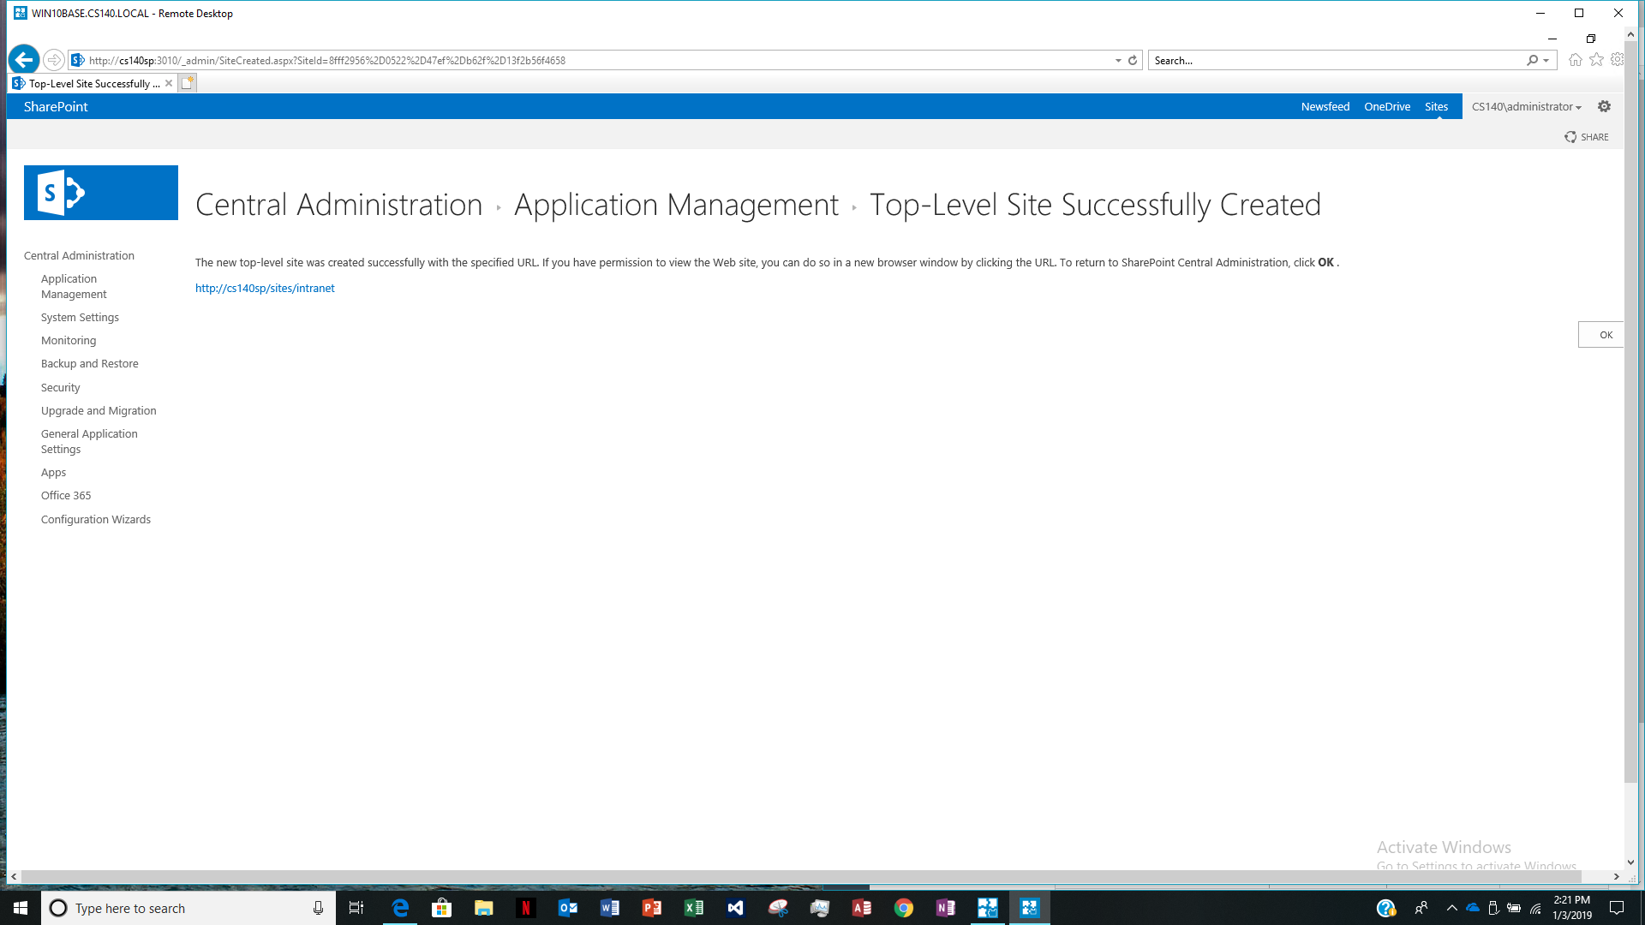Share point Screen web address: http://cs140sp/sites/intranet